Research: New Account Request

Log-In:
- To log-in to the Emory Healthcare Link site, visit https://carelink.emoryhealthcare.org. You will be prompted to utilize two-factor authentication which is required for log-in. Emorys’ recommend two-factor authentication is Duo however, any two-factor authenticaion will work.
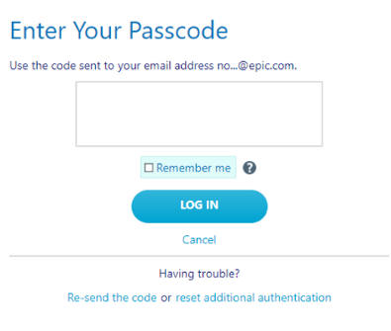
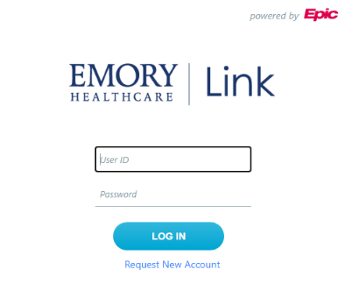

- User Id: Emory Network ID aka N#
- Initial Password: Your Emory Network Password

Landing Page: Onced successfully logged in, you will reach the Emory Healthcare Link landing page aka Home page.

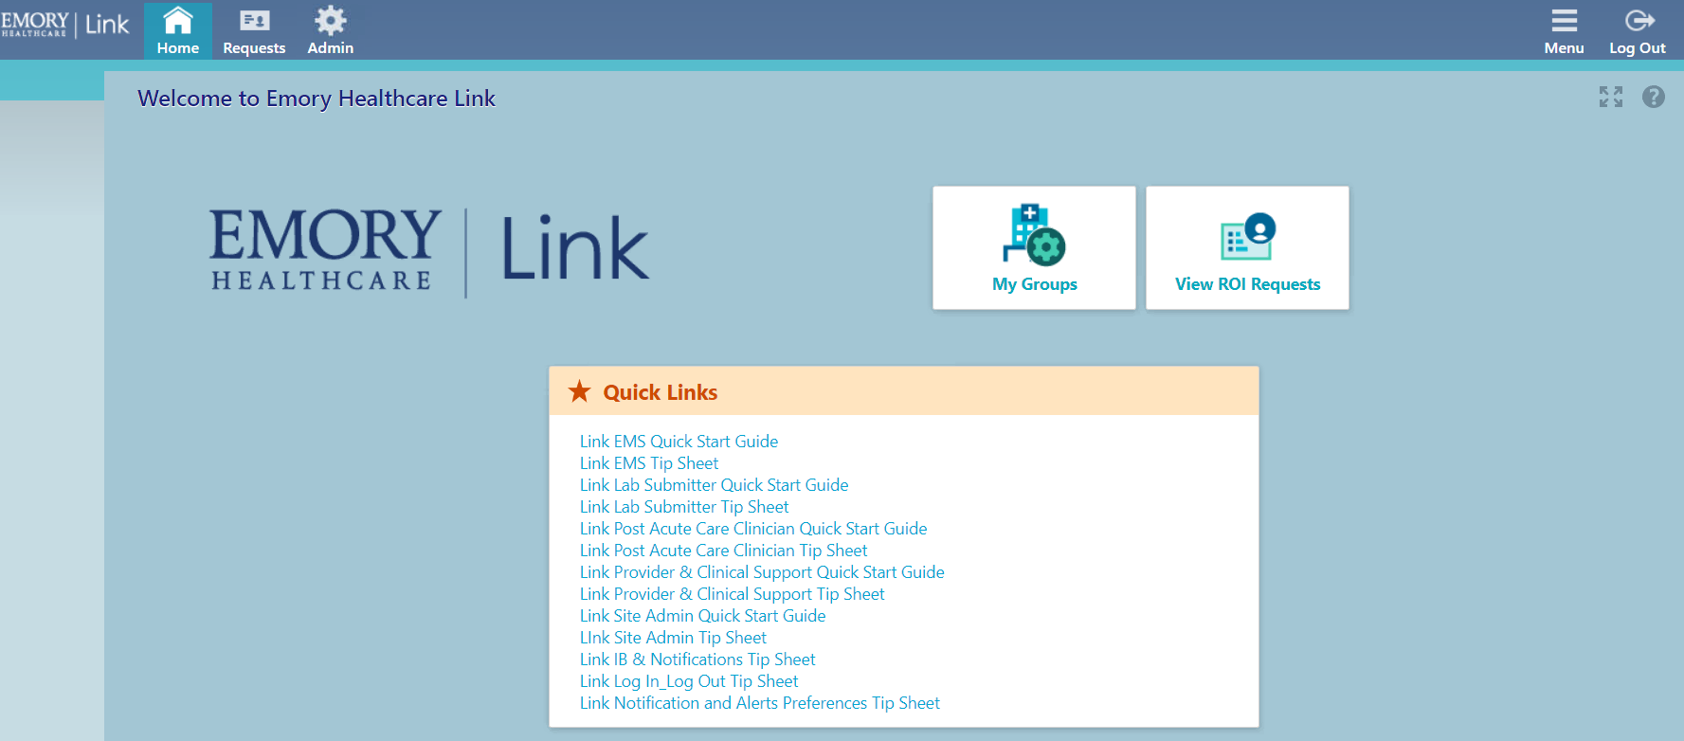

New Account Request via Site Admin Tool:
- Click on the Admin Icon located in the top tool bar.
- From the drop down, click on Account Requests.

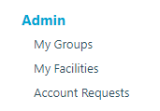

- Click on +Request New Account (Non-OnCore/Non Epic Study Monitors should be submitted as an “Outside Auditor”.

- Click on Request access for a new site (This would be used for Study Monitors whose studies are not in OnCore and not in Epic) It should be submitted as an “Outside Auditor”. The naming convention for the study would be: Company name (space), Study name (space), ROI. ** Please note: Before you submit the Link request, please email the HIM Epic Analyst of the new site info (how the site should be named, i.e., company name (space), study name (space), ROI) so that it can manually be built it in Epic.
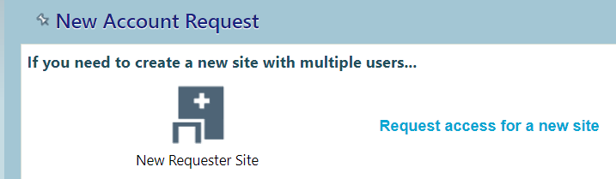

Use the Epic Link Access Request Form and enter the required Site information identified with
- Site Name is the ‘Company requesting access to Emory Link’
- Site Type is ‘Research Study Monitor’ via the drop down
- Phone, Fax, Address is the ‘Compnay Number & Mailing Address’
- Click Next located in bottom right hand corner

- Click on Request access for a research monitor
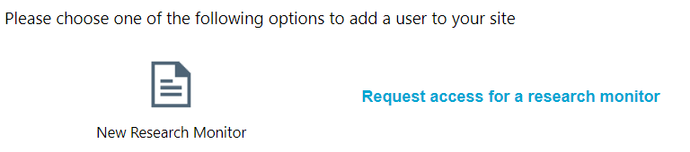

Use the Epic Link Access Request Form and enter the required User information identified with
- Name [Last, First] is the ‘Study Monitor/Outside User Information’
- Work e-mail is the ‘Users email address’
- Work phone is the ‘Company Phone’
- Click Copy site address. This will pull in the site information that you entered in previous step
- User Birth Year is the 4 digit birth year found in ‘Full DOB’
- Requester N# is your Emory Network ID
- Requester Code is REQ1234
- Study ID is found in ‘If for Research/Study, what is the study ID’
- IRB ID is found on the IRB form. At this time, it is not on the Epic Link Access Request From
- Click Add files to upload users Confidentiality Form (required)
- Click Add files again to upload additional supporting documents (optional)
- Click on the box to the left of Make the user a site administrator (user will not be a site admin. an enhancement is in place for next upgrade)
- Click Accept in the bottom right hand corner

- User request review – this screen then opens and gives you the opportunity to review the entry. Add, Edit and Delete buttons are avaialbe.
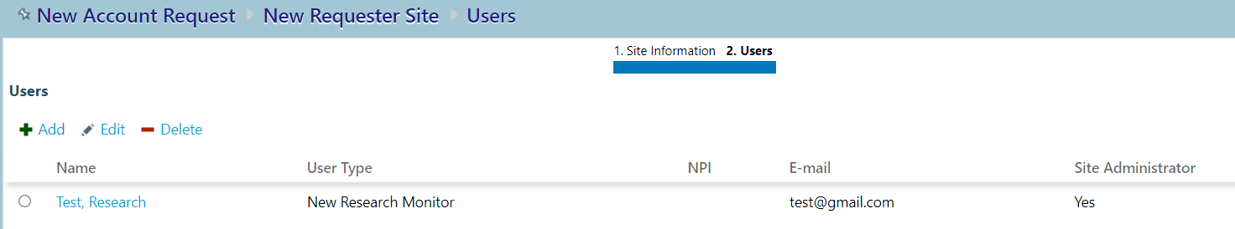
- Click Submit Request located in bottom right hand corner

- What to expect next:
- A Confirmation page will open and display a Reference Number
- The Requester will receive the Research Monitors access information by e-mail within 3-4 business days

Check Status of a New Account Request:
- Click the Admin tool icon in the top tool bar
- Click on the Account Request tab as in previous steps
- Status column populates the current request status
- Click on the users name for additional Account Request Status details
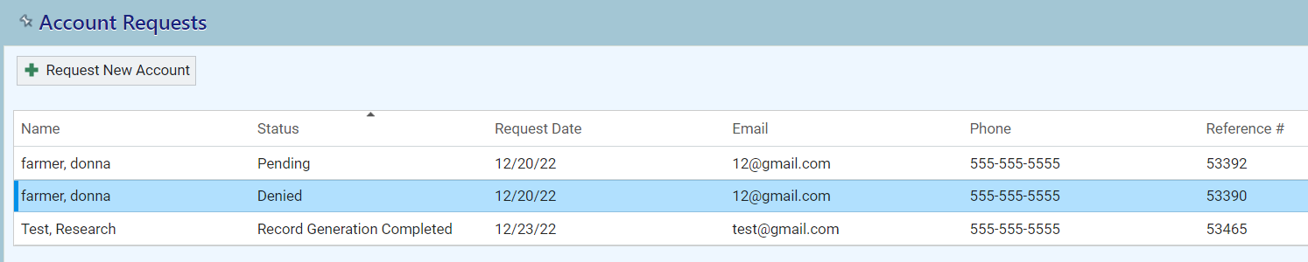

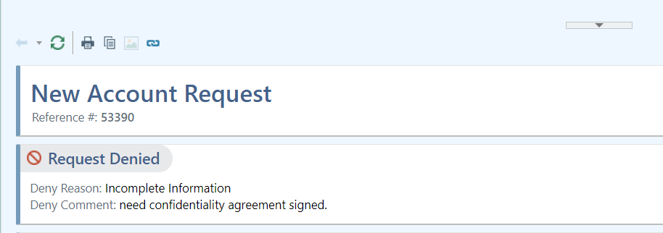

© 2021-2022 Epic Systems Corporation. All rights reserved. PROPRIETARY INFORMATION - This item and its contents may not be accessed, used, modified, reproduced, performed, displayed, distributed or disclosed unless and only to the extent expressly authorized by an agreement with Epic. This item is a Commercial Item, as that term is defined at 48 C.F.R. Sec. 2.101. It contains trade secrets and commercial information that are confidential, privileged, and exempt from disclosure under the Freedom of Information Act and prohibited from disclosure under the Trade Secrets Act. After Visit Summary, App Orchard, ASAP, Beacon, Beaker, BedTime, Bones, Break-the-Glass, Bugsy, Caboodle, Cadence, Canto, Care Everywhere, Charge Router, Chronicles, Clarity, Cogito ergo sum, Cohort, Comfort, Community Connect, Compass Rose, Cosmos, Cupid, Epic, EpicCare, EpicCare Link, Epicenter, EpicLink, EpicWeb, Epic Earth, Epic Research, Garden Plot, Grand Central, Haiku, Happy Together, Healthy Planet, Hey Epic!, Hyperspace, Kaleidoscope, Kit, Limerick, Lucy, Lumens, MyChart, Nebula, OpTime, OutReach, Patients Like Mine, Phoenix, Powered by Epic, Prelude, Radar, Radiant, Resolute, Revenue Guardian, Rover, Share Everywhere, SmartForms, Sonnet, Stork, System Pulse, Tapestry, Trove, Welcome, Willow, Wisdom, With the Patient at Heart, and WorldWise are registered trademarks, trademarks, or service marks of Epic Systems Corporation in the United States of America and/or other countries. Other company, product, and service names referenced herein may be trademarks or service marks of their respective owners. Patents Notice: www.epic.com/patents.

